Science Plan

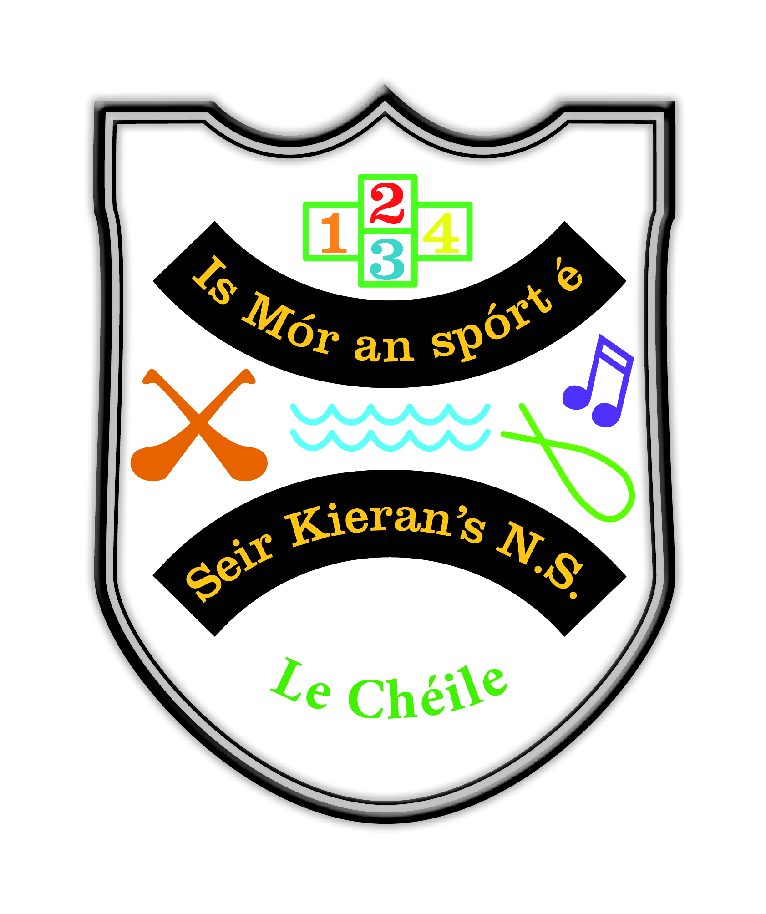

Introductory Statement.
The plan was reviewed by the teaching staff of Seir Kieran’s NS in March/April 2019.
This plan will outline our approaches to the teaching of Science based on the Primary School Curriculum. It will also set out the school’s approach to addressing all the content of the Science curriculum and how we as a three teacher school will teach all strand units within all strands in a multi class, three teacher setting.

Rationale
- To benefit teaching and learning in our school.
- To provide a coherent approach to the teaching of science across the whole school.
- In order to ensure that pupils are given adequate opportunities to develop skills and understanding of concepts as envisaged in the Primary School Curriculum.
- As part of our ongoing curricular review, we had indicated it would be reviewed in the school year 2018/19.

Vision and Aims:
- Vision
Science in our school should
- Help children to work scientifically.
- Develop a broad range of skills of enquiry
- Acquire knowledge of the biological and physical aspects of the world.
We seek to foster the children’s natural curiosity by enabling them to take an active part in their own learning.

- Aims
The aims of science education are:
- To develop knowledge and understanding of scientific and technological concepts through the exploration of human, natural and physical aspects of the environment.
- To develop a scientific approach to problem-solving which emphasises understanding and constructive thinking.
- To encourage the child to explore, develop and apply scientific ideas and concepts through designing and making activities.
- To foster the child’s natural curiosity, so encouraging independent enquiry and creative action.
- To help the child to appreciate the contribution of science and technology to the social, economic, cultural and other dimensions of society.
- To cultivate an appreciation of, and respect for, the diversity of living and non-living things, their interdependence and interactions.
- To encourage the child to behave responsibly to protect, improve and cherish the environment and to become involved in the identification, discussion, resolution and avoidance of environmental problems and so promote sustainable development.
- To enable the child to communicate ideas, present work and report findings using a variety of media.
- To encourage participation in events such as Engineer’s Week and the BT Science Project..

Science Programme

  - Strands and strand units
We teach Science in the following groupings;
- Junior Infants and Senior Infants.
- First, Second and Third Classes.
- Fourth, Fifth and Sixth Classes.
The grids which are attached (Appendix A) outline how we will set about addressing the teaching of the strand units/ strands. They will be taught in a two year cycle in the Infant room and in a three year cycle in the other two classrooms.

1.2 Children’s Ideas
Children’s ideas will nearly always form the starting point for scientific activity. Through the use of prediction, testing, experimenting and observation, children’s ideas can be enhanced, challenged and developed further.

1.3 Practical Investigations
Children in all classes are given opportunities to test theories using materials provided by the school. These are often done in group situations and children are asked to report findings to class groupings. Children of all abilities are encouraged to participate. The concept of fair testing is developed through engaging with experiments at all levels.

1.4 Key methodologies
As a whole staff, we ensure that the key methodologies of the primary curriculum are used.
- Using the environment
- Active learning
- Guided and discovery learning
- Free exploration of materials
- Spiral nature of the curriculum – opportunities to return to earlier learning and to extend and enhance it
- Learning through language
- Every effort is made by teachers to ensure lessons and content are adapted and modified to meet the needs of all students.

1.5 Linkage and integration
Science by its very nature cannot be taught in isolation. Thus teachers will avail of any opportunity to integrate the concepts and activities with other subjects and curricular themes.

1.6 Using the environment
The following features in our local environment will be used as a basis for study and for field trips as deemed appropriate.
- Slieve Bloom mountains
- Telescope in Birr Castle
- Bogs
- Streams - Fuáran
- School garden

Assessment – Looking at children’s work

The teachers are aware that assessment of children’s learning is an essential and continuous part of the teaching and learning process in science. The teachers have a shared understanding of the way in which children’s progress in science can be assessed, documented and reported. Evaluating the suitability of the science programme selected for a particular age group will be undertaken.

Assessment techniques will focus on knowledge objectives.
- Understanding of scientific concepts.
- Competence in the application of experimental and investigative skills.
- Cultivation of important attitudes.

Assessment methods.
- Teacher observation
- Teacher – designed tasks
- Work samples and portfolios
- Pupils engage in self assessment – reflecting on what they have learned and what they still have difficulty in understanding etc.

  - Children with different needs

- This school recognises that children will have special needs and as a staff we will endeavour to cater for them within the constraints pertaining
- Children with special needs will not be withdrawn from science classes and we believe that the science programme is an opportunity for children with special needs to raise their self-esteem.
- As lessons will be age-appropriate, pupils will be expected to engage in all activities.
- Pupils will never be excluded for non-payment of donations or payment for science materials

4. Timetable

From time to time Science may be allocated extra time – seasonal activities eg trips, gardening. Other times it maybe blocked for more time, include times when classes are doing projects. For example in 2019, the school entered a project in the Young BT Science Awards in the RDS.
1 Hour per week will be allocated to the teaching of Science.

5. Resources and equipment

- Equipment is stored centrally in library store.
- As resources are required they will be purchased from school funds.
- List of Science Equipment attached (Appendix 2)

6. Safety

Outdoor work will be based in areas that are accessible for children, teacher and helpers. Only suitable habitats will be selected. It is very important that teachers are made aware of allergies suffered by children - plant and animal allergies.

Staff will ensure that there is adequate supervision of pupils during science activities/field trips, this may involve a number of adults accompanying a class.

Pond investigation;

- Children to work in small groups under supervision of an adult.
- Only one group of 4 to 6 children should dip at a line. Other children should be positioned well back from the edge and be actively engaged in observing weather conditions, plant and animal life.
- Use only safe areas of the surrounding banks which children can pond-dip or collect samples of water.
- Children and adults should wear protective rubber boots.
- Skin infections, grazes or cuts should be covered.
- Children and adults make aware of the position of life belts and safety notices in the area.
- Children should wash their hands before and after handling animals, plant or soil.
- Children should not handle anything that may be hazardous.
- Ponds with algal bloom or water pollution to be avoided.

Light
- Looking at the sun or bright beams of light prohibited.
- Plastic mirrors to be used.
- Looking at the sun through lenses strictly prohibited.
- Children to be made aware of the dangers of sunburn.

Electricity and Magnetism.
- Never to touch the bare metal of a plug or a switch especially when hands are wet.
- Never to use electrical appliances without adult supervision.
- Never fly kites or use fishing rods near overhead wires.
- Avoid playing near electricity sub-stations.
- Batteries must not be cut open
- Batteries to be disposed in a safe manner – in Battman.
- Rechargeable batteries not to be used for investigations.
- Adults only to strip the plastic covering from the leads (which are composed of insulated wire)

Magnets
- Magnets to be stored carefully with their keepers.
- If stored in pairs, unlike poles, should be put together in box.

Forces
When doing forces, care must be taken because of the risk of injury resulting from moving objects.

Heat
When organizing tests involving the use of hot water the children should use water that is safe for them.

Designing and Making.
- During these activities pupils will work with a wide variety of materials and tools.
- Tools such as craft knives, glue guns and hacksaws will only be used by children under the direct supervision of the teacher.
- Demonstration on the safe use of tools by teacher before allowing their use in designing and making tasks.
- Tools to be stored in a secure area
- Children only to have access to tools when being supervised.
- Cultivation of a safe working environment.

7. Individual teachers Planning and Reporting
- Teachers will refer to the whole school plan and the curriculum documents for science information and guidance for their long and short term planning.
- They will also be guided by the grid in Appendix A, as outlined earlier so as to ensure continuity and avoid overlapping.

8. Staff development

Staff are willing to avail of any further professional development opportunities available in this area.

9. Parental involvement/Community links
- The Science Plan is available for parents to view on the school website.
- School work /exhibits are displayed on the school website.
- The school avails of opportunities to invite parents with particular skills in this area to visit the school and speak to the pupils.

Success criteria
We believe this plan will make a difference to the teaching and learning of science in our school.
- Teachers’ preparation will be based on this plan
- Procedures outlined in this plan will be consistently followed
- Children will participate actively and willingly in science lessons.
- Feedback from teachers/parents/pupils will enable us to determine its success..
- Inspectors’ suggestions/reports will be discussed and any recommendations adopted.

Implementation
- Roles and Responsibilities
This Plan is supported and developed by Board of Management, Teachers and Parents.
It is implemented by teachers with the support of the Board of Management and Parents.
It is monitored by Teachers/Inspectors.

- Timeframe
This revised plan will be fully implemented from September 2019 onwards.

Review
It will be necessary to review this plan on a regular basis to ensure optimum implementation of the science curriculum in the school.
- Roles and Responsibilities
- Teachers
- Pupils
- Post holder/plan co-ordinator – Mrs. Williams

- Timeframe
This plan was reviewed in March/April 2019. It was signed off on at a Board of Management meeting on the 10th of June 2019. It will be constantly monitored and a formal review will take place again in 2023.

Ratification and Communication
This plan was communicated to and ratified by the Board of Management on the 10th of June 2019. Parents were informed of this review via the June newsletter and the end of Year Board of Management report for the 2018/19 school year.

